UNDERWRITING APPLICATION FEE
  I (we) authorize Merchant Partners (Company) to initiate a debit entry of $50.00 to my (our) Credit Card, Checking or Savings Account selected below at the Financial Institution indicated, to debit such account. I (we) acknowledge that the origination of debits to my (our) account must comply with the provisions of United States law. If I (we) do not have sufficient funds to cover the transfer or if my (our) Financial Institution for any other reason refuses to honor this transfer, I (we) will separately pay a $15.00 failed invoice charge. |  |  |  |  | Merchant Name:
 |  |  |  |  | Address:
 |  |  |  |  | City: |  | State: | Zip Code:
PAYMENT INFORMATION
Debit My Account: | ❶ Expiration Date *: | ❷ Credit Card Account Number *: |  |  |  | ❸ Security Code *:
VISA
MasterCard
 | ❶ Bank ABA Number *: | ❷ Bank Account Number *: |  |  |  | Bank Name:
Checking
Savings
*See below for an explanation of where to locate the required information on your credit card or check.
Explanation of Credit Card Numbers  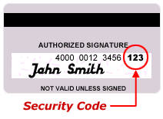  ❶ Expiration Date — The month and year on the front of your card in which it will expire.  ❷ Account Number — Embossed on the front of your card.  ❸ Security Code — A three digit number found on the reverse of your card on the signature strip or a four digit code on the front of American Express cards. |  |  |  | Explanation of Check Numbers  ❶ Bank ABA Number — This is a nine digit number separated by a bar and a colon.  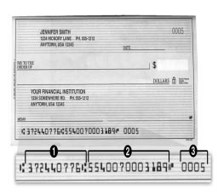  ❷ Account Number — This number may appear as the second, first or third series of numbers. Please read carefully.  ❸ Check Number — Matches number in the upper right corner of check. NOT REQUIRED FOR ACH.
DEBIT AUTHORIZATION
This authorization is to remain in full force and effective until Company has received written notification from you of its termination in such time and in such manor as to afford the Financial Institution and Merchant Partners a reasonable opportunity to act upon it. Company deems this time to be seven (7) business days.
Autorized Signature: |  |  | Name (Please Print): |  |  |  | Today’s Date:
Title: |  |  | Drivers License/Issuing State: |  |  |  | Birth Date:
 |  |  | /
If a second signature is required for authorization
Autorized Signature: |  |  | Name (Please Print): |  |  |  | Today’s Date:
Title: |  |  | Drivers License/Issuing State: |  |  |  | Birth Date:
 |  |  | /
Questions Regarding This Debit Should be Addressed to:
Merchant Partners
12424 Wilshire Blvd, Suite 1170
Los Angeles, CA 90025
(310) 826-2323 / customerservice@merchantpartners.com
Please fax completed form and a voided check to (310) 826-0404

